Story

Date | 24 July 2026
Team ID | Khushi Bhatia
Project Name | Food Ordering Behaviour and Consumer Trends: A Structured Analysis of Choices and Habits
Maximum Marks | 5 Marks

Activity 1: Story Design:
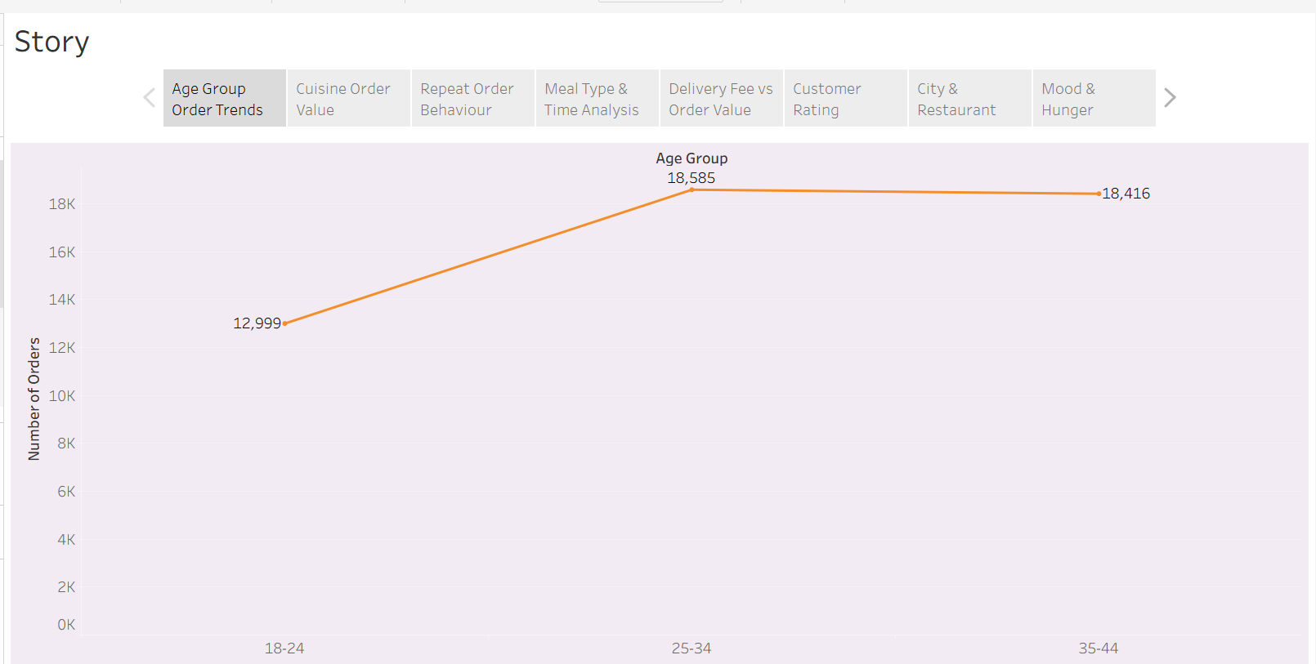

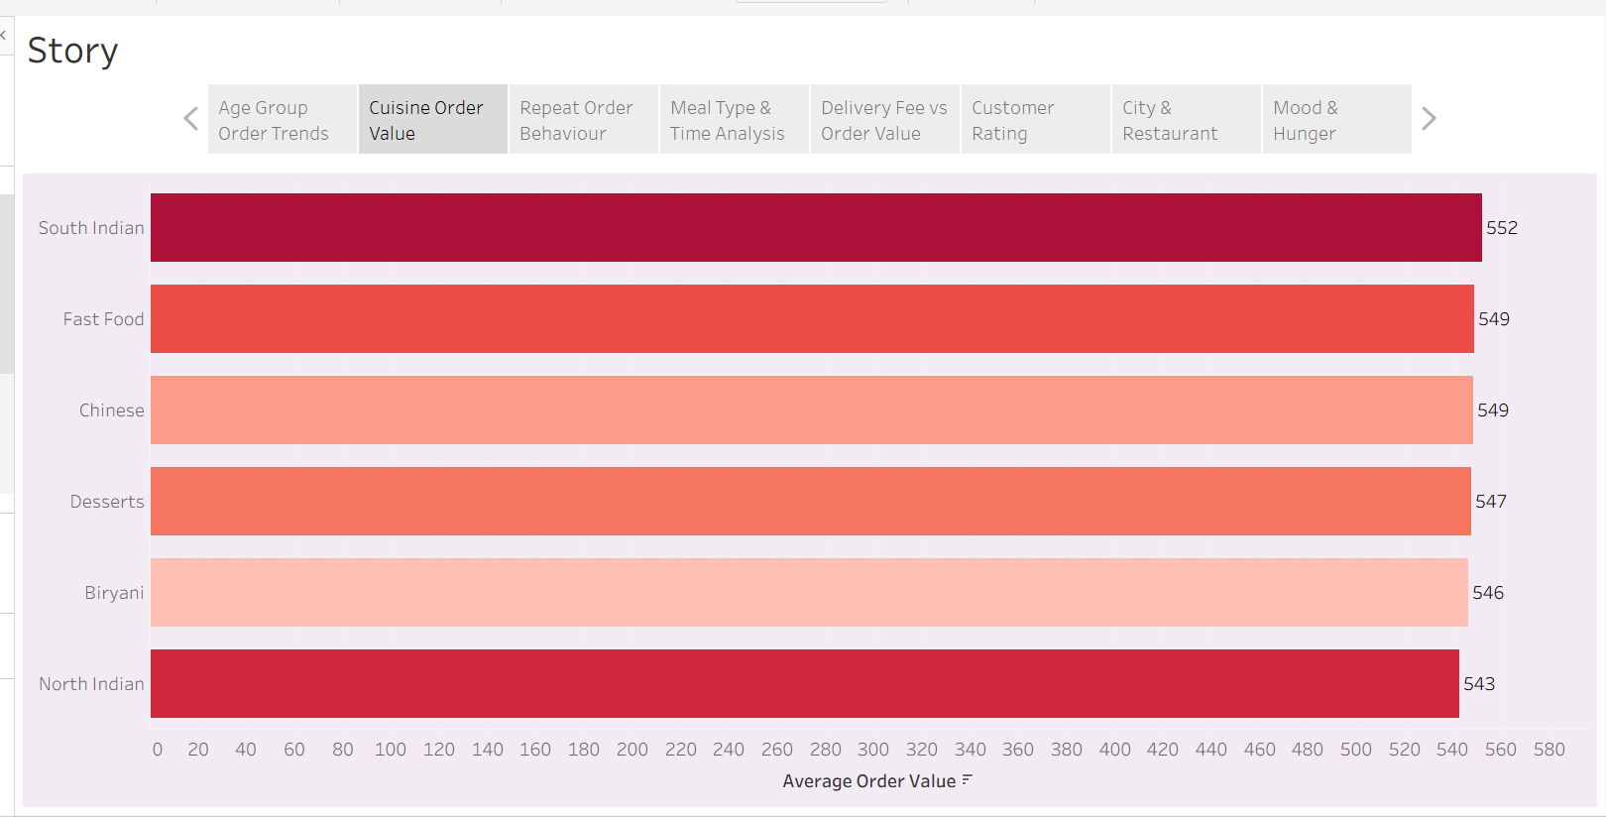
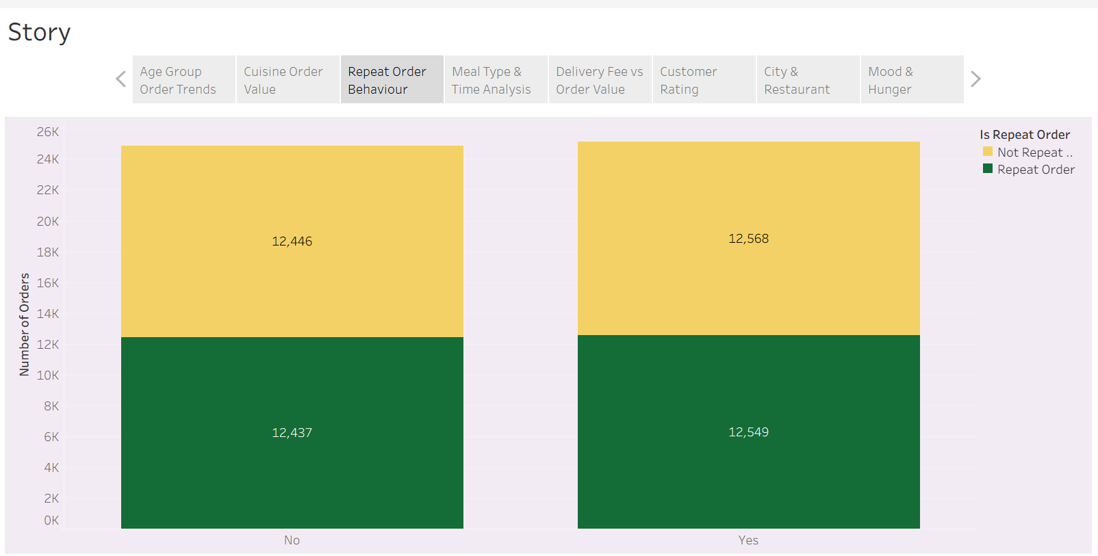

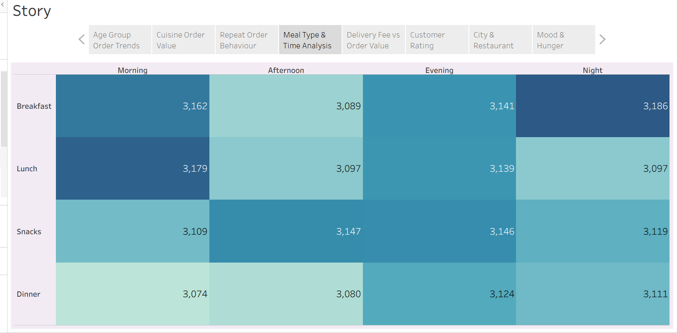
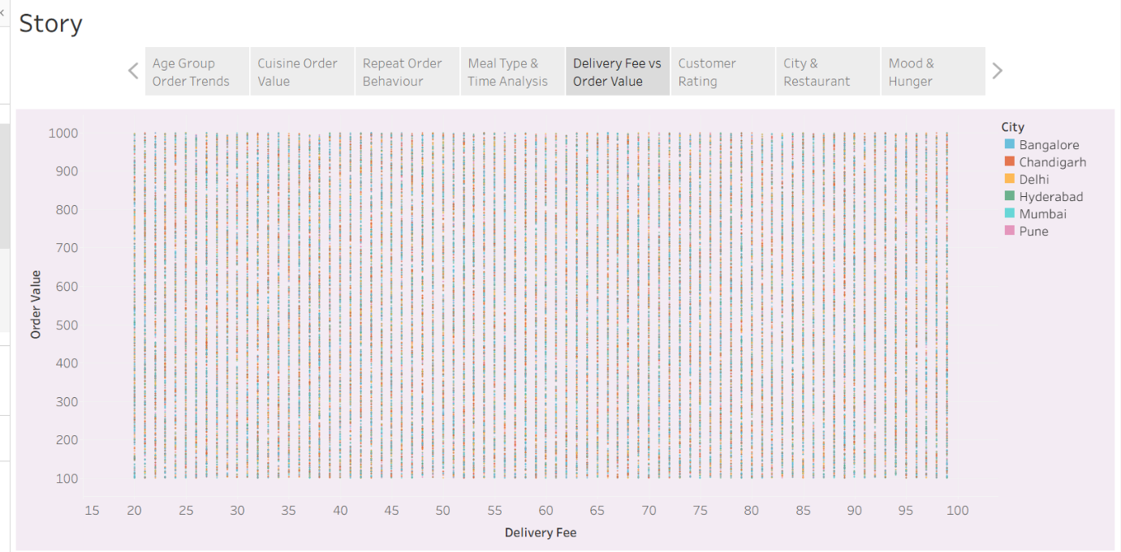
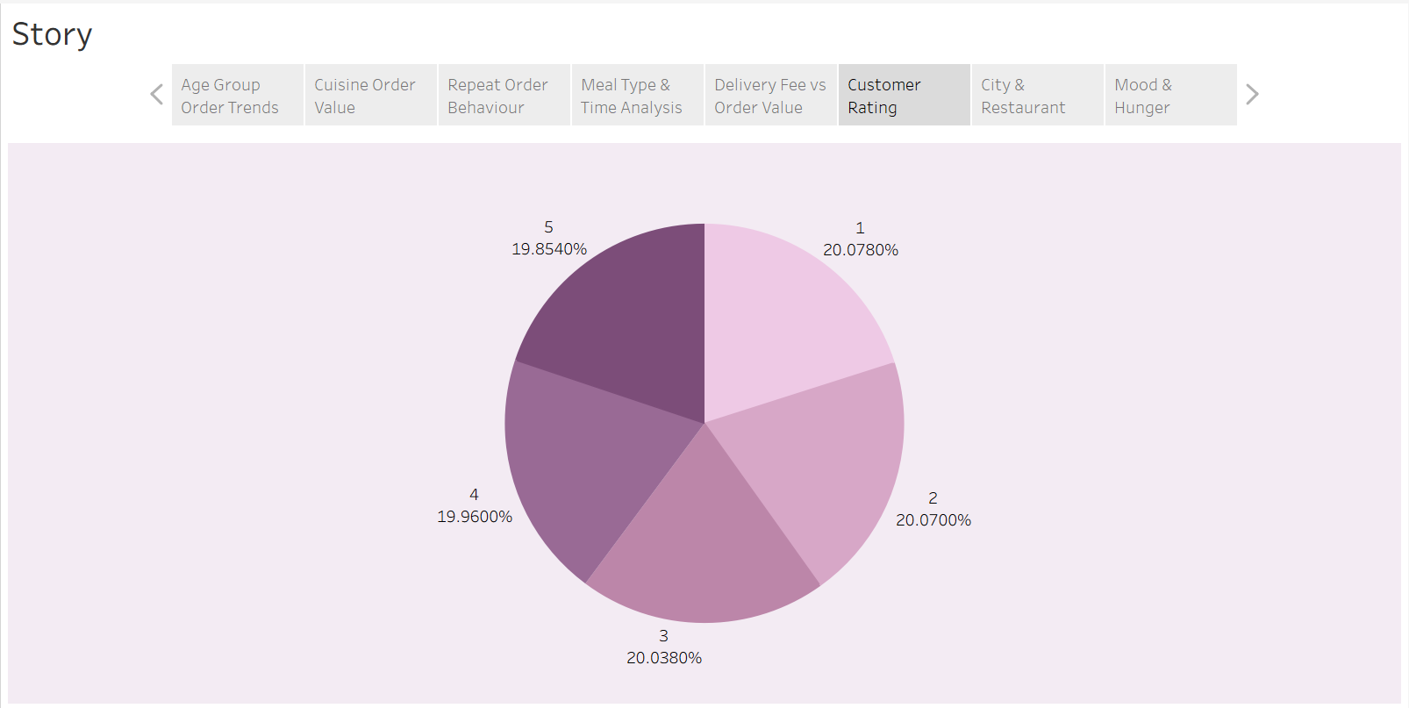

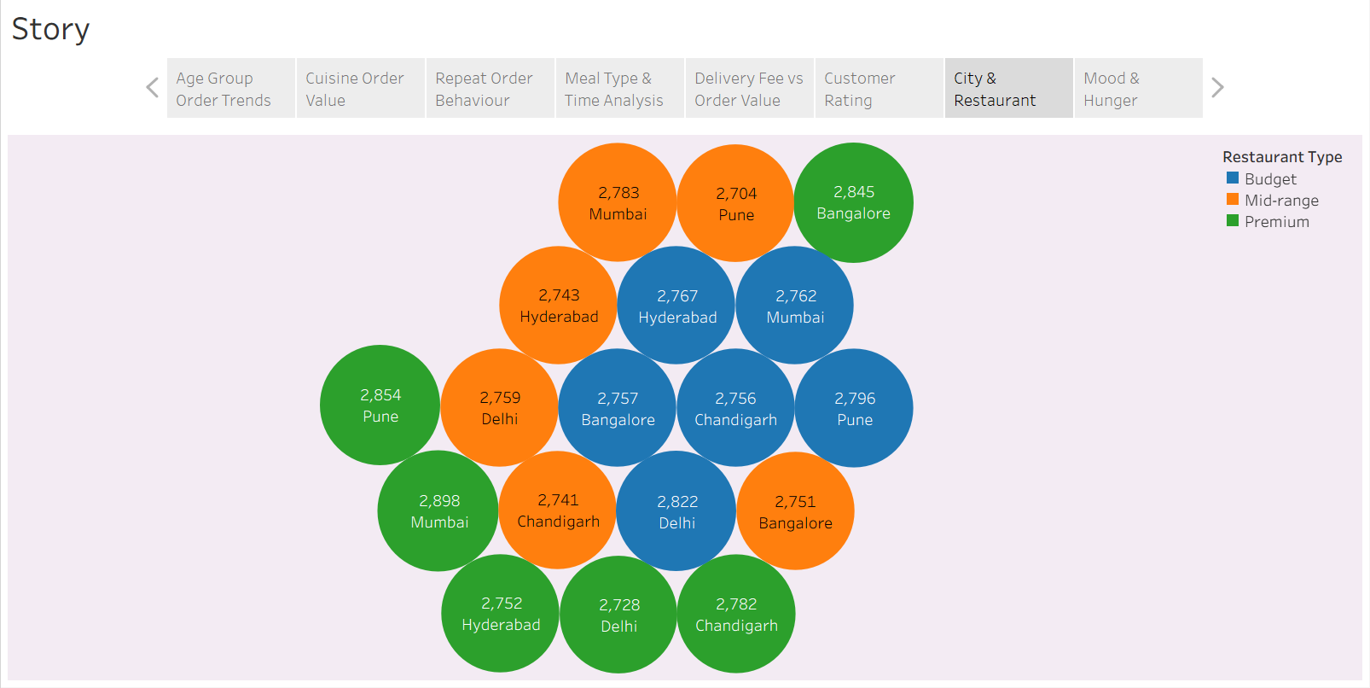
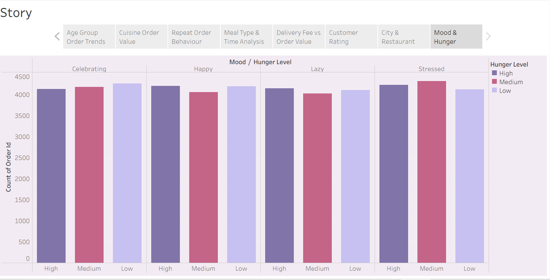

Tableau Story Narrative & Observations
The Tableau Story presents customer ordering behaviour through a sequence of interactive visualizations. It transforms raw food ordering data into meaningful business insights, helping users understand customer preferences, ordering patterns, and factors influencing food delivery decisions.
Based on the story points, the key observations are:
- Customer Age Trends (Q1): The line chart shows how order volume varies across different age groups, helping identify the most active customers.
- Cuisine Preferences (Q2): The bar chart compares average order values across cuisines, highlighting the food categories that generate higher customer spending.
- Discount Impact (Q3): The stacked bar chart indicates how discounts influence repeat orders, supporting the evaluation of promotional campaigns.
- Meal Time Patterns (Q4): The heatmap reveals peak ordering periods for different meal types, enabling better operational planning.
- Delivery Fee and Order Value (Q5): The scatter plot helps understand the relationship between delivery charges and customer spending.
- Customer Satisfaction (Q6): The pie chart summarizes customer ratings, providing an overview of overall customer feedback.
- City and Restaurant Analysis (Q7): The bubble chart identifies cities and restaurant types with higher order volumes.
- Consumer Behaviour (Q8): The side-by-side bar chart demonstrates how mood and hunger level influence customer ordering decisions.

Activity 2:
Publish Story on Tableau Public
Food Ordering Behaviour Analysis Story | Tableau Public
https://public.tableau.com/views/FoodOrderingBehaviourAnalysisStory/Story?:language=en-US&:sid=&:redirect=auth&:display_count=n&:origin=viz_share_link

